**Sprint 4 Plans**

**Team Number 111**

|  |  |
| --- | --- |
| Student Number | Team Member Name |
| n9458816 | Alexandria Griffiths |
| n9588868 | Akash Mehta |
| n9378171 | Ronald Leung |
| n8599751 | Lorenz Esparcia |
| n9437681 | Alexander Stevens |

Tutor: Prakash Bhandari

Version: 1.2

Date: 26/10/2016

[Sprint Plan](https://docs.google.com/document/d/1LtI_fbHOUZh5js-fV-oaXcgwt21DQaIjtHkykHCLf7w/edit#heading=h.2s8eyo1)

[Sprint 4](https://docs.google.com/document/d/1LtI_fbHOUZh5js-fV-oaXcgwt21DQaIjtHkykHCLf7w/edit#heading=h.17dp8vu)

[Current Velocity:](https://docs.google.com/document/d/1LtI_fbHOUZh5js-fV-oaXcgwt21DQaIjtHkykHCLf7w/edit#heading=h.3rdcrjn)

Story ID: #3 Notification – Permit Approval

Story ID: #4 Access – Physical Approved Permit

Story ID: #6 Notification – New Violation

Story ID: #16 Notification – Digital to Violator

Story ID: #18 Notification – New Permit Request

Story ID: #23 Ensure Physical Permit for Vehicle Owner

Story ID: #25 Automated – Overdue Notification

Story ID: #26 Notification – New H&S Issue

Story ID: #29 Upon Resolution, Enter Additional Info

[Sprint Plan Update 26/10/2016](https://docs.google.com/document/d/1LtI_fbHOUZh5js-fV-oaXcgwt21DQaIjtHkykHCLf7w/edit#heading=h.17dp8vu)

**Sprint 4: Payment System and Notification System**

Total Story Points: 24

Total Hours:   20

**Current Velocity:** 24 Story Points per Sprint / 20 Hours per Sprint

**Story ID: #3 Notification – Permit Approval**

|  |  |  |  |
| --- | --- | --- | --- |
| **Task ID** | **Task Description** | **Estimate** | **Taken** |
| **1** | Scaffold email message | 0.5 | 0.5 |
| **2** | Retrieve recipient email from database with a query, using permit_id | 1 | 1 |
| **3** | Code automatic email to recipient | 0.5 | 0.5 |
|  | Story Points: 2 Total Hours: | 2 | 2 |

**Story ID: #4 Access – Physical Approved Permit**

|  |  |  |  |
| --- | --- | --- | --- |
| **Task ID** | **Task Description** | **Estimate** | **Taken** |
| **4** | Create buttons on approved permit entries that redirect to print page | 1 | 1 |
| **5** | Create new page that pulls relevant information and displays in columns | 1 | 1 |
| **6** | Develop CSS for print-friendly display | 2 | 2 |
|  | Story Points: 1 Total Hours: | 4 | 4 |

**Story ID: #6 Notification – New Violation**

|  |  |  |  |
| --- | --- | --- | --- |
| **Task ID** | **Task Description** | **Estimate** | **Taken** |
| **7** | Scaffold email message | 0.5 | 0.5 |
| **8** | Retrieve admin users from database using query | 1 | 1 |
| **9** | Code automatic email to all admin user accounts | 1 | 1 |
|  | Story Points:  2  Total Hours: | 2.5 | 2.5 |

**Story ID: #16 Notification – Digital to Violator**

|  |  |  |  |
| --- | --- | --- | --- |
| **Task ID** | **Task Description** | **Estimate** | **Taken** |
| **10** | Scaffold email message | 0.5 | 0.5 |
| **11** | Retrieve recipient email from database using query | 1 | 1 |
| **12** | Code automatic email to recipient | 0.5 | 0.5 |
|  | Story Points:  2 Total Hours: | 2 | 2 |

**Story ID: #18 Notification – New Permit Request**

|  |  |  |  |
| --- | --- | --- | --- |
| **Task ID** | **Task Description** | **Estimate** | **Taken** |
| **13** | Scaffold email message | 0.5 | 0.5 |
| **14** | Retrieve admin users from database using query | 1 | 1 |
| **15** | Code automatic email to all admin user accounts | 0.5 | 0.5 |
|  | Story Points:  2 Total Hours: | 2 | 2 |

**Story ID: #23 Ensure Physical Permit for Vehicle Owner**

|  |  |  |  |
| --- | --- | --- | --- |
| **Task ID** | **Task Description** | **Estimate** | **Taken** |
| **16** | Enable access to print page from non-admin accounts | 1 | 1 |
| **17** | Inform user of process via automated email | 0.5 | 0.5 |
|  | Story Points: 1 Total Hours: | 1.5 | 1.5 |

**Story ID: #25 Automated – Overdue Notification**

|  |  |  |  |
| --- | --- | --- | --- |
| **Task ID** | **Task Description** | **Estimate** | **Taken** |
| **18** | Organise user violations according to ‘overdue’ criteria | 0.5 | 1 |
| **19** | Inform user of process via automated email | 0.5 | 0.5 |
|  | Story Points: 2 Total Hours: | 1 | 1.5 |

**Story ID: #26 Notification – New H&S Issue**

|  |  |  |  |
| --- | --- | --- | --- |
| **Task ID** | **Task Description** | Estimate | **Taken** |
| **20** | Scaffold email message | 0.5 | 0.5 |
| **21** | Retrieve admin users from database using query | 1 | 1 |
| **22** | Code automatic email to all admin user accounts | 0.5 | 0.5 |
|  | Story Points: 4 Total Hours: | 2 | 2 |

## Story ID: #29 Upon Resolution, Enter Additional Info

|  |  |  |  |
| --- | --- | --- | --- |
| **Task ID** | **Task Description** | **Estimate** | **Taken** |
| **23** | Create buttons on approved permit entries that redirect to edit page | 1 | 1 |
| **24** | Retrieve relevant report data from database with a query, using health_id | 0.5 | 1 |
| **25** | Create new page that pulls relevant information to set the default values of input fields | 1 | 0.5 |
|  | Story Points: 8 Total Hours: | 2.5 | 2.5 |

**Sprint Plan Update 26/10/2016**

* Taken Sections of the Stories were filled out
* The progress of the sprint can be found in the Burndown Chart provided (Figure 1)
* Table 1 is a table for reference for Sprint 4’s Progress



Table 1: Sprint 4 Progress Table

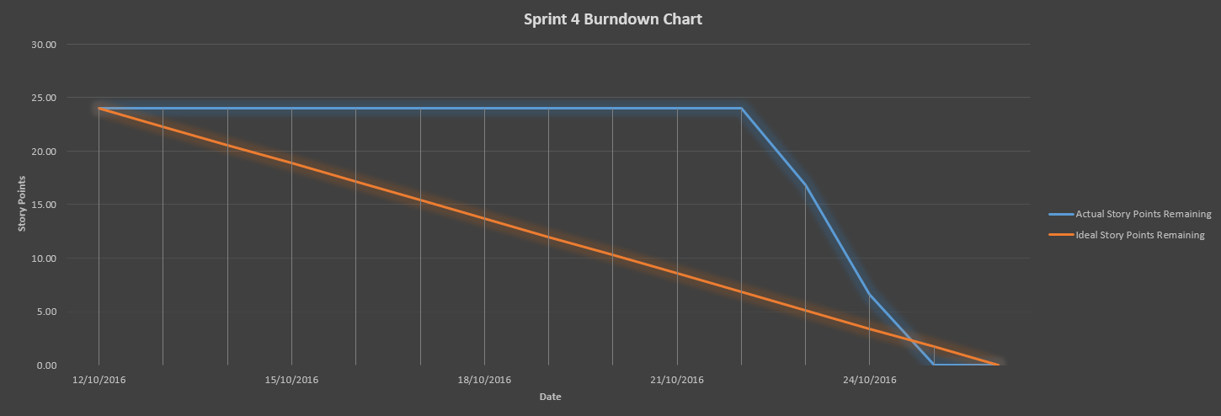

Figure 1: Sprint 4 Burndown Chart (Story Points vs Date)